Ideation Phase
Define the Problem Statements

Date | 22 December 2025
Team ID
Project Name | MediConnect
Maximum Marks | 2 Marks

Customer Problem Statement Template
To define the core problems faced by patients and doctors in managing medical appointments and healthcare access, and use those insights to guide the development of MediConnect, a centralized doctor appointment booking platform.

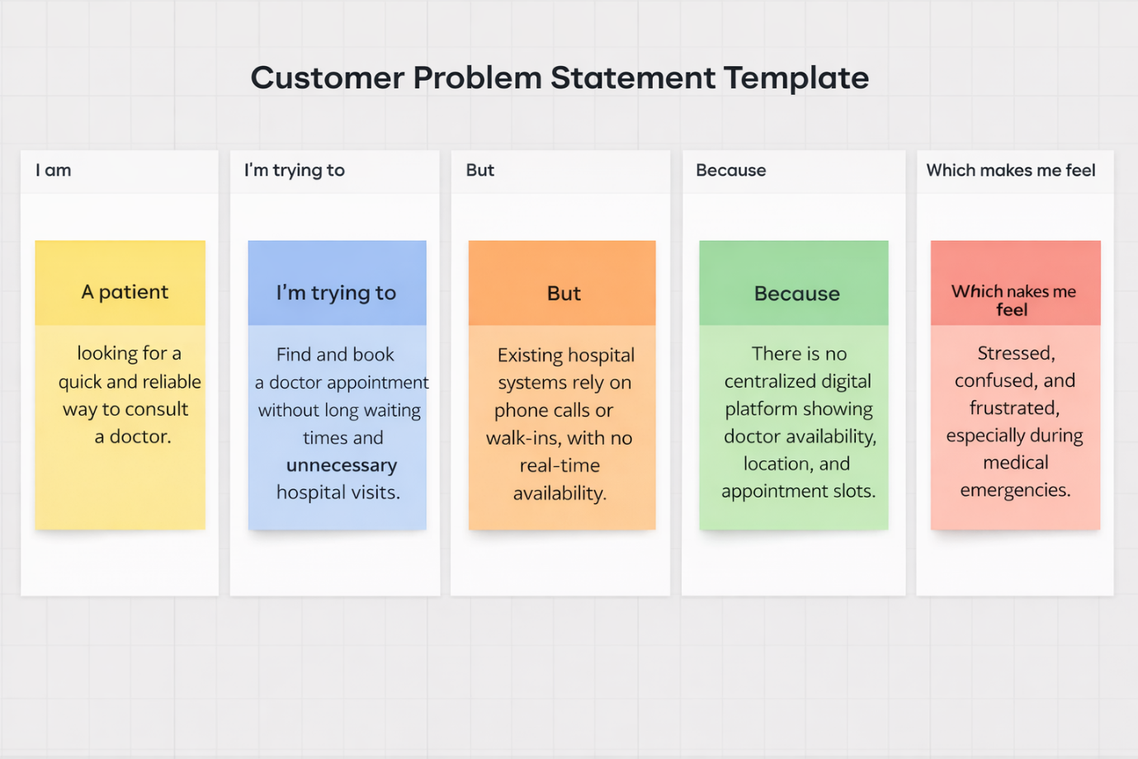

Problem Statements
Problem Statement (PS) | I am (Customer) | I’m trying to | But | Because | Which makes me feel
PS-1 | a patient seeking medical care | book a doctor appointment quickly | I struggle to find available doctors nearby | appointment booking is unorganized and mostly offline | stressed and anxious during emergencies
PS-2 | a working professional patient | manage my appointments efficiently | I forget schedules and follow-ups | there is no centralized system for reminders | confused and frustrated
PS-3 | a doctor | manage patient appointments smoothly | appointments overlap or get missed | bookings are done manually | overwhelmed and inefficient
PS-4 | a specialist doctor | showcase my expertise to patients | patients cannot view my profile clearly | limited visibility and digital presence | undervalued and disconnected

Outcome of Ideation
These problem statements highlight the need for:
- A centralized digital platform for appointment booking
- Role-based access for patients, doctors, and admins
- Profile visibility for doctors
- Efficient appointment tracking and reminders

